PL/SQL:

**Exercise 1: Control Structures**

**Scenario 1:** The bank wants to apply a discount to loan interest rates for customers above 60 years old.

* + **Question:** Write a PL/SQL block that loops through all customers, checks their age, and if they are above 60, apply a 1% discount to their current loan interest rates.

**CODE:**

BEGIN

    FOR c IN (

        SELECT CustomerID

        FROM Customers

        WHERE MONTHS_BETWEEN(SYSDATE, DOB) / 12 > 60

    ) LOOP

        UPDATE Loans

        SET InterestRate = InterestRate - 1

        WHERE CustomerID = c.CustomerID;

        DBMS_OUTPUT.PUT_LINE('Interest rate updated for CustomerID: ' || c.CustomerID);

    END LOOP;

    COMMIT;

END;

/

**OUTPUT:**

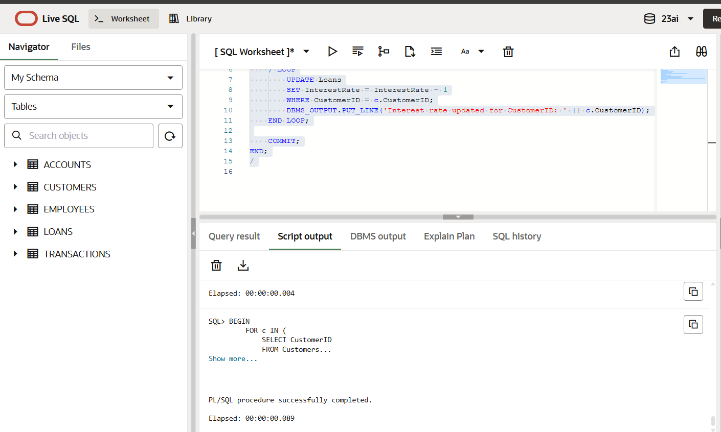

**Scenario 2:** A customer can be promoted to VIP status based on their balance.

* + **Question:** Write a PL/SQL block that iterates through all customers and sets a flag IsVIP to TRUE for those with a balance over $10,000.

CODE:

BEGIN

FOR c IN (

SELECT CustomerID

FROM Customers

WHERE Balance > 10000

) LOOP

UPDATE Customers

SET IsVIP = 'Y'

WHERE CustomerID = c.CustomerID;

DBMS_OUTPUT.PUT_LINE('CustomerID ' || c.CustomerID || ' promoted to VIP.');

END LOOP;

COMMIT;

END;

/

OUTPUT:

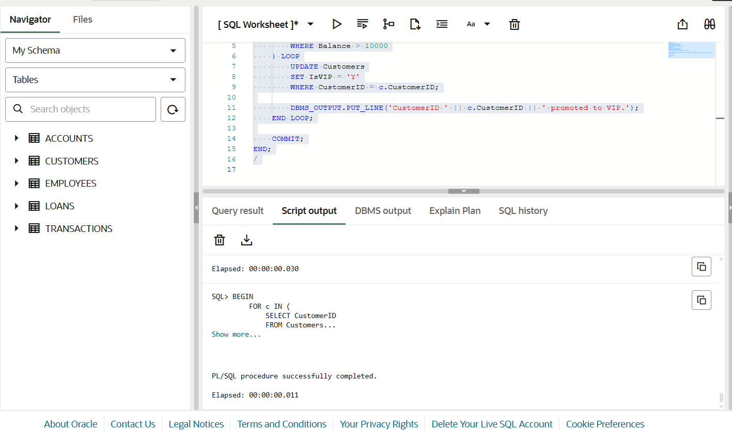

**Scenario 3:** The bank wants to send reminders to customers whose loans are due within the next 30 days.

* + **Question:** Write a PL/SQL block that fetches all loans due in the next 30 days and prints a reminder message for each customer.

CODE:

DECLARE

v_due_date_threshold DATE := SYSDATE + 30;

v_name Customers.Name%TYPE;

BEGIN

FOR l IN (

SELECT L.LoanID, C.Name, L.EndDate

FROM Loans L

JOIN Customers C ON L.CustomerID = C.CustomerID

WHERE L.EndDate <= v_due_date_threshold

) LOOP

DBMS_OUTPUT.PUT_LINE('Reminder: Dear ' || l.Name ||

', your loan (ID: ' || l.LoanID ||

') is due on ' || TO_CHAR(l.EndDate, 'DD-MON-YYYY'));

END LOOP;

END;

/

OUTPUT: